T10 Weekly Owner Report
Superyacht Project Management | Free PM Templates & Documents for Yacht and Shipyard Projects

Companion to the lesson 'Measuring Progress and Writing the Weekly Owner Report' (Superyacht Project Management series, project2-me.com). Use it together with the Physical Progress Calculator (T10, xlsx).

How to use this template
- Part A is the blank report. Page 1 is the front sheet: keep it to one page so the Owner can read it in five minutes.
- Agree the traffic-light rules (Part C) with the Owner before the first report. Rate each dimension against the rules, never by feel, and never average colours.
- Decisions required from the Owner always appear on page 1, even when there are none. Each needs a 'needed by' date taken from the schedule and a line on what moves if it is late.
- Physical progress is measured monthly with the calculator. In the weeks between, report movement on the few critical items only.
- Every fact in the report should already have been discussed with the Yard at the weekly site meeting. The report is the Owner's document; the assessment stays owner-side.
- Part B shows a completed example for the fictional yacht YP-48 at week 61 (month 14).

Part A: Weekly Owner Report (Blank)
Field | Entry | Field | Entry
Project |  | Report no.
Week / ending |  | Contract month
Author |  | To
Copy to |  | Next report

Status against agreed rules
Dimension | Colour | Trend | Reason (one line) | What would change it
Schedule
Milestones and payments
Design, GT and weight
Quality
Changes

Headline
What changed this week. What it means for delivery. What we need from you.

Decisions required from the Owner
Ref | Decision | Options | Recommendation | Needed by | If late
Decisions taken since the last report:

Progress
Planned | Measured | Index | Critical path float | Change since last week | Measured on
Critical item | Planned % | Measured % | Note

Milestones and payments
No | Milestone | Baseline | Forecast | Evidence | Status

Risks and open issues
Top risk | Trend | Action | Owner
Open issues: ___ open, ___ new, ___ closed this week, oldest ___ days (log in appendix).

Look-ahead: next two weeks
Date | Event (inspection, test, delivery, visit) | Who attends

Photo record
Six to eight photos from the fixed viewpoints. Keep originals (with their file date) in the archive.
Ref | Date | Location | What it shows | Why it matters

Appendices
☐ Open issues log
☐ Milestone and payment table (T6)
☐ Change log summary
☐ Drawing register extract and GT / weight margins (T7)
☐ Physical progress calculation (T10 xlsx)
☐ Weekly site meeting minutes

Part B: Example (YP-48, illustrative), week 61
Fictional example. Illustrative project: Project YP-48 is fictional. Its parameters are chosen from publicly reported industry ranges so the numbers are realistic, but no real yard, owner or yacht is described.
Progress is on an index where the total weighted scope = 100; money on an index where the contract price = 100. Class society and flag are not chosen in the example. Measured values are invented for teaching.
Field | Entry | Field | Entry
Project | YP-48, 48 m motor yacht | Report no. | 61
Week / ending | Week 61, Friday 3 March 2028 | Contract month | 14 of 30
Author | Owner's representative | To | Owner
Copy to | Build captain | Next report | Friday, week 62

Status against agreed rules
Dimension | Colour | Trend | Reason (one line) | What would change it
Schedule | Amber | Down | Superstructure about 2 weeks behind on the critical path; Yard second shift started this week | Red if the last two superstructure sections are not welded and inspected by end of week 63
Milestones and payments | Green | Same | Milestone 3 claimed; 5 of 6 evidence items accepted; joint inspection booked | Amber if the joint inspection finds a deficiency
Design, GT and weight | Amber | Same | GT margin 2.7 (warning below 3.0); weight margin 0.6 (warning below 1.0) | CR-06 would take the weight margin to 0.3
Quality | Green | Same | No findings overdue
Changes | Green | Same | No work on unpriced instructions; CR-06 on hold until decided
Note. The Yard's own report rates the schedule green, assuming the second shift recovers the time. Under the agreed rules a started, resourced recovery plan gives amber, not green.

Headline
Superstructure welding is about two weeks behind plan and sits on the critical path; the Yard started a second shift this week and still forecasts joining in month 16, while on the current rate we forecast the second half of month 16. Milestone 3 (main engines) is claimed, with five of six evidence items accepted and the joint inspection booked for Tuesday. We need three decisions from you: the master bathroom stone by the end of week 62, and the AV/IT specification and the tender garage door change by the end of week 63.

Decisions required from the Owner
Ref | Decision | Options | Recommendation | Needed by | If late
D-14 | Master bathroom stone | Sample A or sample B (weights in the sample register) | Sample B: lighter, same supplier lead time | End of week 62 | Stone and joinery for the area start late; interior has about 1 month float
D-15 | Sign off the AV/IT specification | Issued spec rev C as is, or with the two open comments | Sign rev C; handle comments as a later change | End of week 63 | Uses the 1 month float week by week; then commissioning and delivery move
D-16 | CR-06, larger hydraulic tender garage door | Accept or reject once the Yard's price and the naval architect's check arrive (expected week 62) | Decide on the check; weight effect +0.3 of 0.6 remaining | End of week 63 | Structural work must finish before the hot-work cut-off at month 16
Decisions taken since the last report: CR-05, sun-deck bar enclosure, rejected (would have taken the tonnage estimate to about 502.6 GT).

Progress (month-end measurement)
Planned | Measured | Index | Critical path float | Change since last week | Measured on
53.8 | 51.2 | 0.95 | 0 (critical); 6 paths at 1 month | Index 0.96 to 0.95 (month 13 to 14) | End of month 14
Critical item | Planned % | Measured % | Note
Aluminium superstructure (4.4) | 86 | 78 | 2 sections left to weld and inspect; second shift from week 61
Generator and stabilizer installation (5.3) | 50 | 40 | Generators landed; stabilizers not yet fitted (1 month float)
Interior detail design (2.4) | 100 | 85 | Waiting for D-14 and D-15
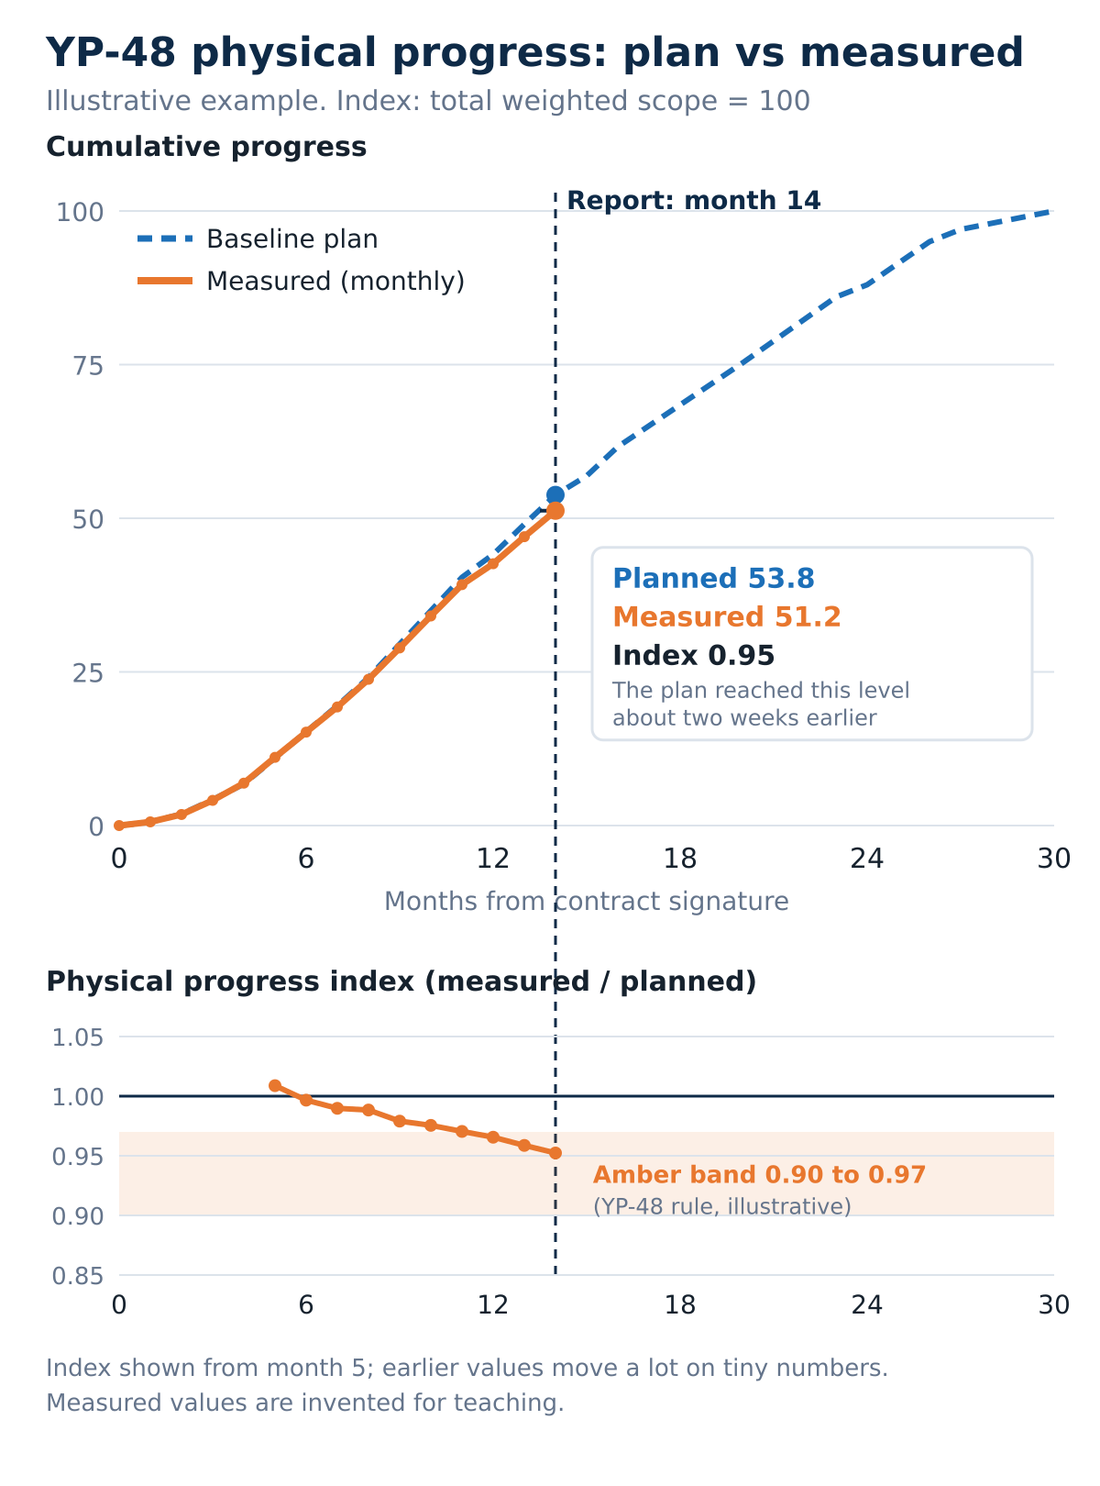

Milestones and payments
No | Milestone | Baseline | Forecast | Evidence | Status
3 | Main engines installed and aligned | Month 14 | Month 14 | 5 of 6 accepted; joint inspection record open | Claimed
4 | Hull and superstructure joined | Month 16 | Yard: month 16. Owner's side: second half of month 16 | Not started | Planned
 | Hot work complete (not a payment) | Month 16 | Moves with milestone 4 |  | Planned
Paid to date: 25 of 100 (milestones 1 and 2). Claimed: 15 (milestone 3).

Risks and open issues
Top risk | Trend | Action | Owner
Superstructure rate does not recover; joining, paint, launch and delivery move | Up | Weekly section count; review recovery at week 63 | Yard PM / owner's rep
Weight margin used up by late interior and exterior requests | Same | Every request carries a weight and GT line before decision | Naval architect
Late AV/IT specification uses the order float | Up | D-15 on page 1 until signed | Owner
Open issues: 14 open, 3 new, 5 closed this week, oldest 26 days (log in appendix).

Look-ahead: next two weeks
Date | Event (inspection, test, delivery, visit) | Who attends
Week 62, Tue | Joint inspection, milestone 3 (engine room) | Yard, owner's rep, captain
Week 62, Thu | Class inspection, superstructure sections | Yard, class; owner's rep attends
Week 63 | Design Studio visit: samples and AV/IT specification | Design Studio, owner's rep, captain
Week 63, Fri | Superstructure checkpoint (red trigger) | Yard PM, owner's rep

Photo record (captions only in this example)
Ref | Date | Location | What it shows | Why it matters
YP48-W61-01 | Week 61 | Superstructure, aft | Last two sections tacked, welding started | The critical-path item behind plan
YP48-W61-02 | Week 61 | Viewpoint 2, starboard side | Same view as weeks 57 to 60 | Shows the week's change
YP48-W61-03 | Week 61 | Engine room, port engine | Engine on seating, tag visible, shaft fitted | Supports milestone 3 (not the proof itself)
YP48-W61-04 | Week 61 | Engine room, starboard | Generator sets landed | Progress on item 5.3
YP48-W61-05 | Week 61 | Yard store | Stabilizer units in storage, covered | Equipment protection
YP48-W61-06 | Week 61 | Joinery workshop | Guest cabin panels in prefabrication | Package at 85%

Part C: Traffic-light rules
Agree these with the Owner before the first report. The YP-48 thresholds are illustrative; set your own. A colour follows the current record, not the promise: a recovery plan earns amber once it is resourced, dated and started.
Dimension | Green | Amber | Red
Schedule | Critical path forecast on or before baseline; index 0.97 or above | Critical path behind, with a recovery plan that is resourced, dated and started; or index 0.90 to 0.97 | Forecast delivery after the contract date on current performance; or no realistic recovery plan; or index below 0.90
Milestones and payments | Next milestone forecast on its date; evidence on track | Evidence item overdue, or a milestone forecast late without moving delivery | Milestone claim disputed, or forecast late in a way that moves delivery
Design, GT and weight | Both margins above warning thresholds | A margin inside its warning band | Estimate above the GT target or the weight budget
Quality | Findings closed within the agreed period | Findings overdue, or a repeat finding | A finding that blocks a milestone or a class approval
Changes | All changes priced and signed before work | Work proceeding on an instruction not yet priced | A disputed variation affecting price or delivery

Your rules (Blank)
Dimension | Green | Amber | Red
Schedule
Milestones and payments
Design, GT and weight
Quality
Changes
- Rate each dimension separately; do not average colours. If you show an overall colour, use the worst of schedule, milestones and quality, or explain why not.
- Explain every change of colour in one line: what changed and what would change it back.
- Do not leave a dimension amber for months: the recovery either works or the colour moves.

